Resident On-Call Binder Info
Procurement and Processing of Renal Biopsies

Need to take with you:
- A blank renal requisition (black shelves where the cyto/flow sheets are under ‘renal’)
- A biohazard bag containing 1 of each media from our fridge (IF, ZF, EM)
- Cart with dissecting scope, hard wax, cotton-tipped applicators, blade, saline, pipette
- Gloves

Before the biopsy:
Someone will page and say they need someone for a renal biopsy. Make sure to ask if it’s for a native or transplant kidney (we routinely do not go to transplant biopsies) and if it’s for function or mass (we do not go for masses but cytology may need to be contacted) and when they’d like a preliminary on the light microscopy (tissue in zinc-formalin). Ask for patient name, MRN and their room number (and directions if you need them).

If this can happen during the week, have them schedule with the gross room Monday morning.

If it’s happening over the weekend:
- Get all the required materials and take the cart to the floor where biopsy is being done.
- Request the clinician fills out the requisition form to completion.
***YOU NEED 4 PATIENT LABELS FROM STAFF***
- Plug in microscope and make sure the light comes on
- Label containers and requisition with the stickers you acquired while they’re setting up (the importance cannot be stressed enough)
- Break off a square of wax and place it under the microscope. Pipette a small bolus of saline on to the wax, about the size of a quarter (keeps biopsy moist while looking at it).
- Get out a blade for triage and line up the containers
- The specimen will be presented to you in one of two ways:
  - They will remove the tissue from the device themselves and hand it to you on the wooden end of a cotton tip applicator
  - You will use the wooden end of the cotton tip applicator (from your cart supplies) and remove the biopsy from the device by gently rolling the end of the applicator over the piece of tissue.
- Roll the tissue back off the applicator into the bolus of phosphate buffer waiting for you on the slide, under the scope.
- Look for glomeruli—1-2 mm globe shadows with/without blood or semi-circles off the edge of the core (see image A below)
  - If in medulla—will be striped tissue with no globes (see image B below)- request another biopsy
  - If in fat—will look yellow and lobulated - request another biopsy
  - Need 1-2 glomeruli for EM, 1-2 for IF, and remaining (as many as possible) for routine histology.
  - Use blade to cut off a small piece (1-2 glomeruli) for IF first, then another piece (1-2 glomeruli) for EM (try to not touch fixatives to blade). Put remaining core(s) in zinc formalin.
***Before you leave double check everything has patient label!!!***
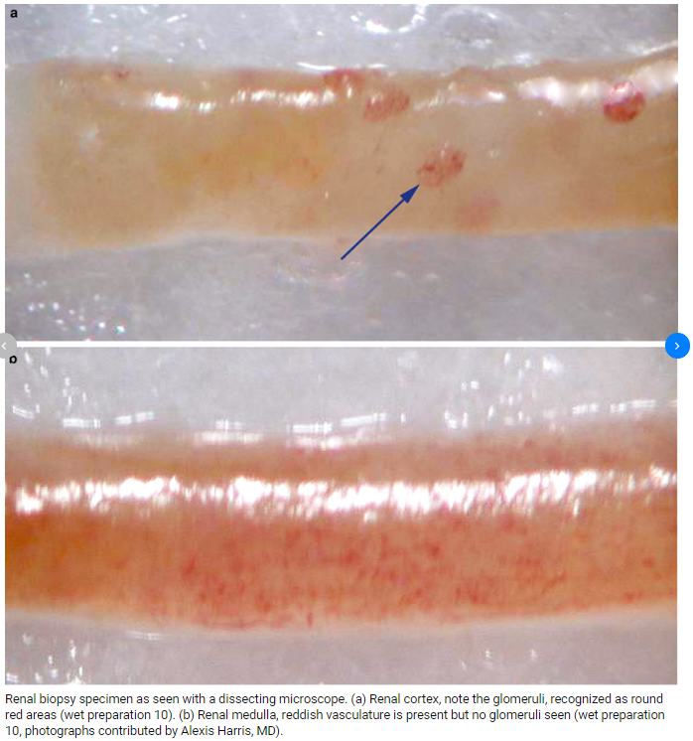

Back in the gross room/Accessioning:
- Native vs Transplant
  - If native vs allograft is not selected on biopsy paperwork-- read clinical history.
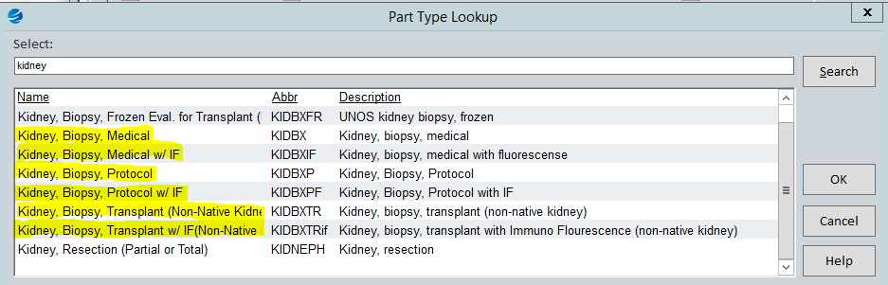
  - Medical: native kidney for medical (function) diagnosis
  - Protocol: transplant kidney for routine biopsy, surveillance, annual bx, etc
  - Transplant: transplant kidney for non-routine diagnosis

- w/ IF
If IF specimen is received accession as such (ie kidney, medical w/ IF). Will get a cassette #2 with the kidney. 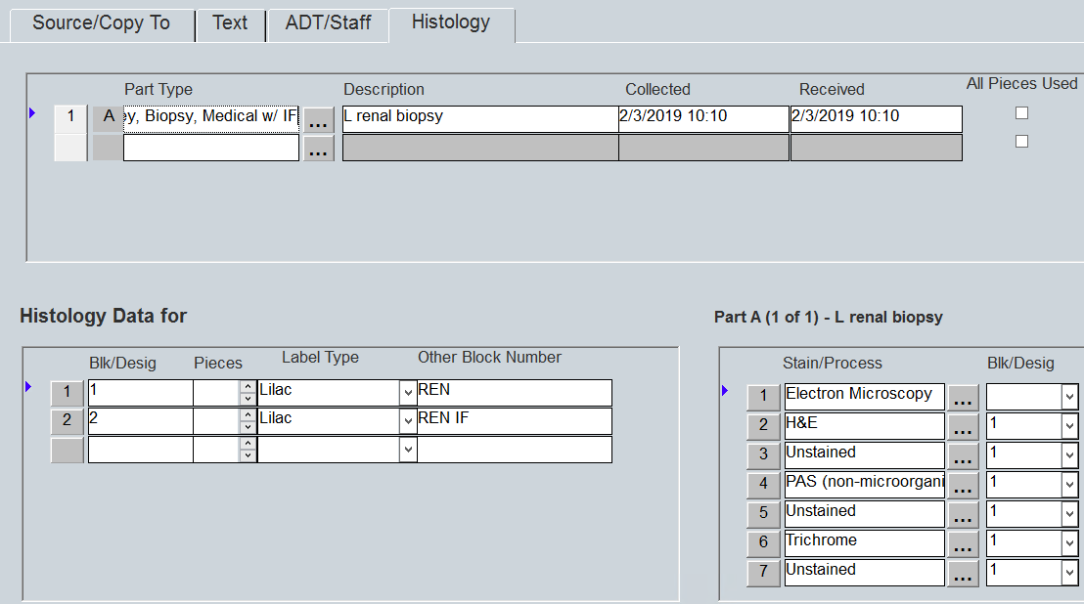
  - Add to gross- “Additionally submitted in Michel’s media is a similar tissue for immunofluorescence.”
  - Put the IF container and cassette #2 in biohazard bag and place in histo fridge and fill out white board on front. Do NOT gross specimen into cassette or put in formalin.

- w/ EM
  - Add under histology tab, at the bottom of stains list, type EM, put in our fridge in Renal EM bucket
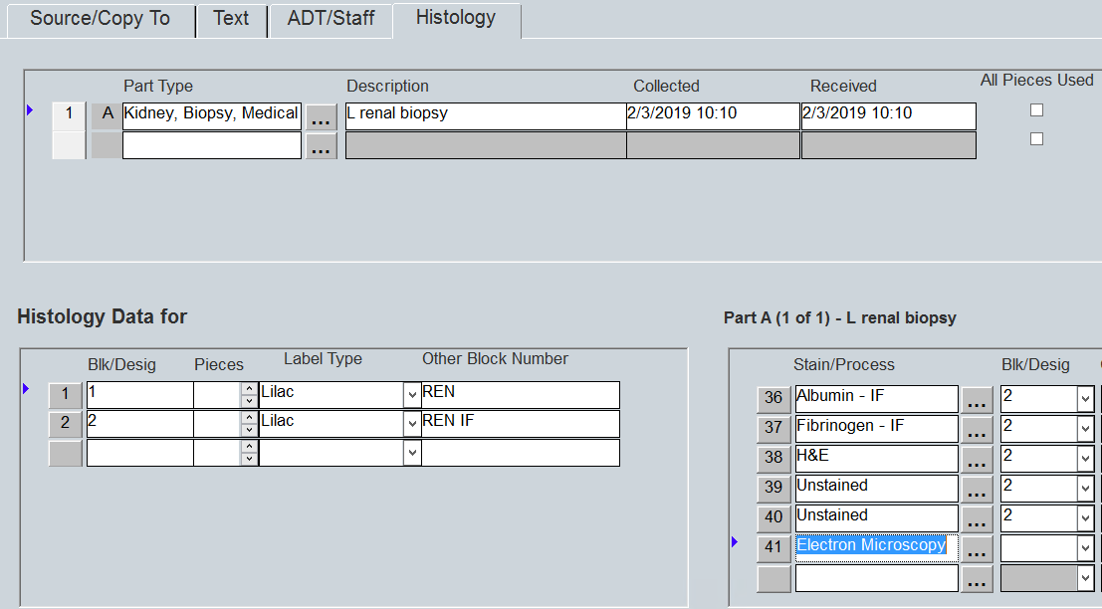
  - Add to gross (“Additionally submitted in gluteraldehyde is a similar tissue for electron microscopy.”

- Grossing zinc formalin specimen
  - Gross biopsy in container with ZF on top as routine biopsy, place into cassette and put on biopsy processor or leave overnight for fixation as necessary (communicate with attending!)

